Event information sheet
Main leader: JAIP
WP number: WP1
Task number: T1.4.
Name of the event/title: Stakeholder meeting

Type of activities:
Date: 04/10/2018
Place (venue): Třeboň
Size of audience (participants): 12 participants
Type of audience:
Represented sector: industry working with renewable sources and energy efficiency
Country addressed: Czech Republic
Event dimension:
Dissemination means: direct invitation to participants from companies mail lists, phone calls

Event description: Workshop with stakeholders was held on 4th October, 2018 from 16:45 to 18:15. In the first part was presented project E-FIX (presentation in Czech language enclosed), followed by discussion with particitpants (questions about project, presentations of activities which do companies in the field of RES and savings. It was confirmed possible future cooperation, especially with Innogy and ČEZ.
Webpage: www.jaip.cz, www.ekoport.cz

Photos: please insert the photo by clicking the icon in the middle of the field

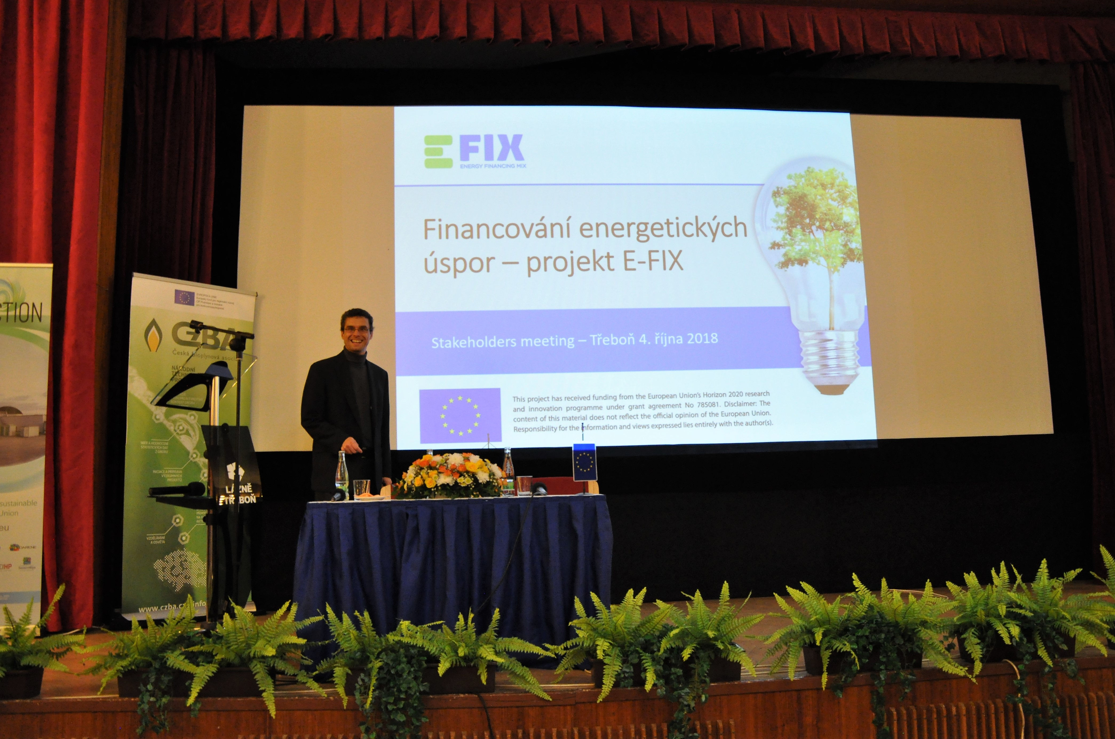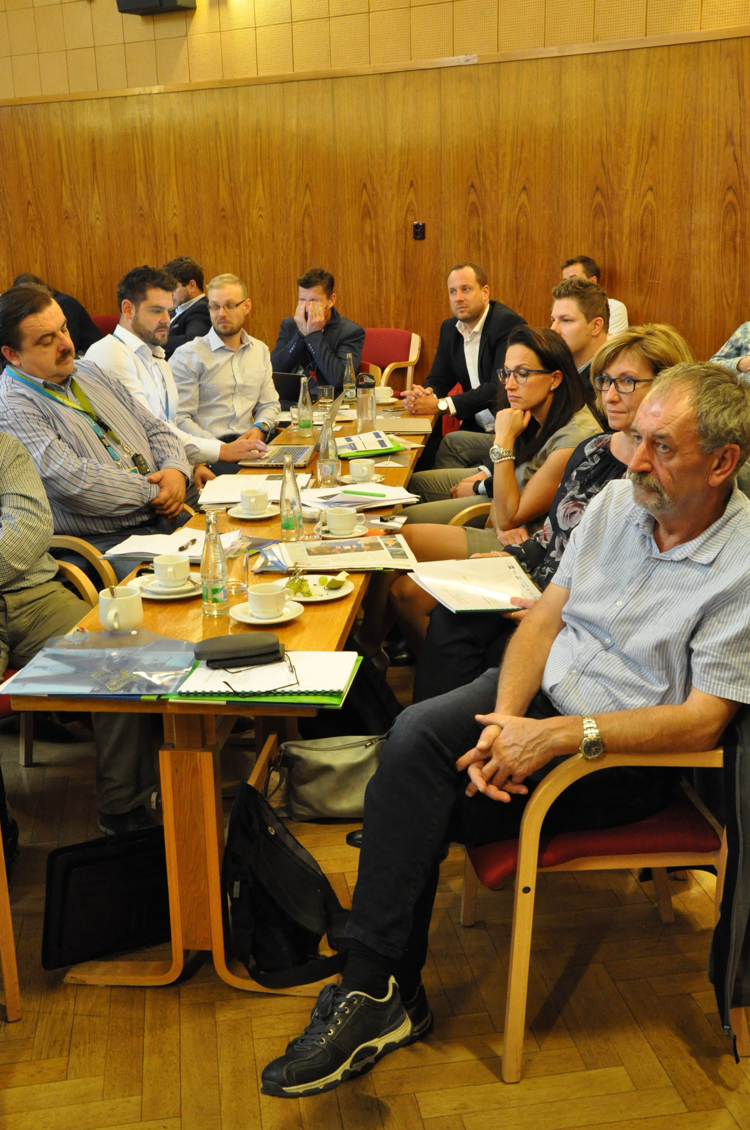

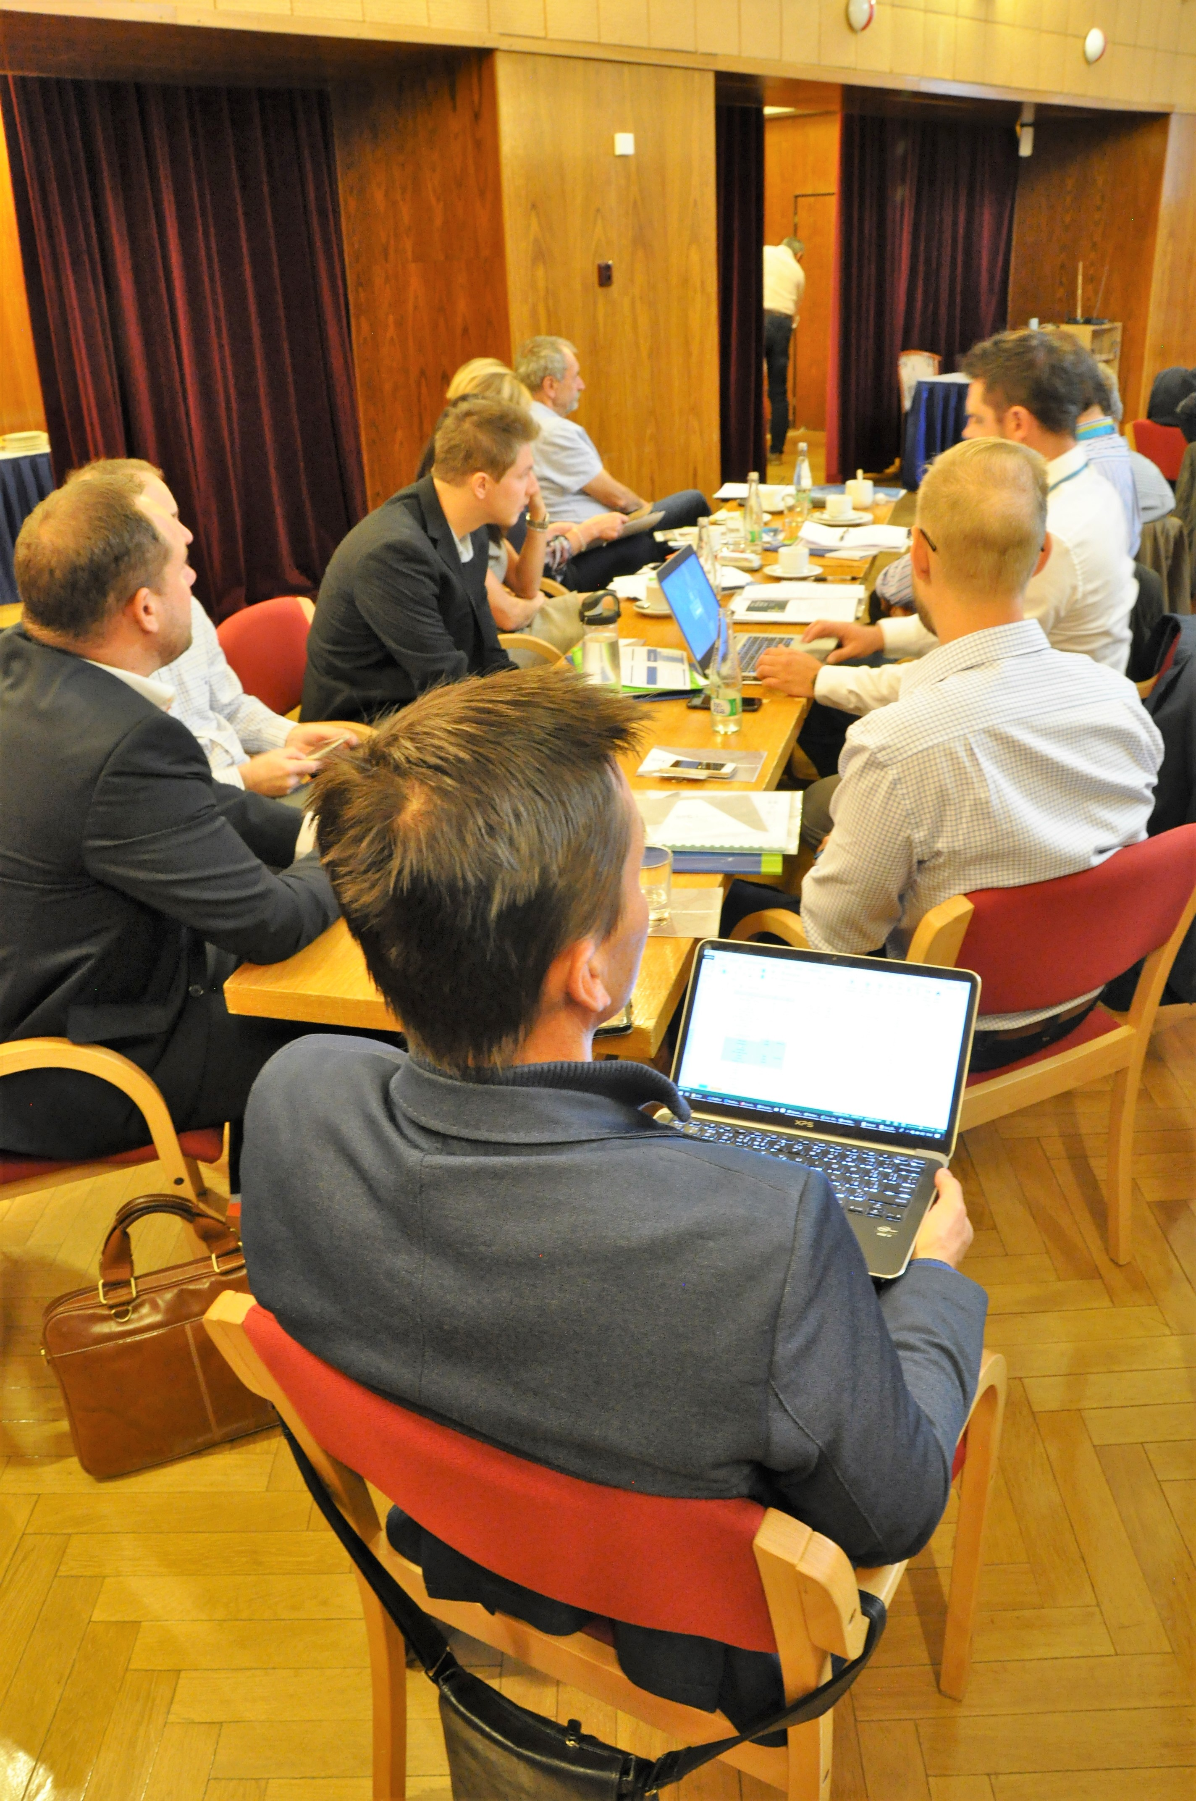

Attachments: fill in to all email attachments.
Name of the attachment | Language | To be placed on the  public E-FIX web | If “yes” choose the dissemination mode
 |  |  | Choose where to place
 |  |  | Choose where to place
 | czech |  | Choose where to place
 |  |  | Choose where to place
 |  |  | Choose where to place
 |  |  | Choose where to place
 |  |  | Choose where to place
 |  |  | Choose where to place
 |  |  | Choose where to place
 | Czech |  | Events
 |  |  | Choose where to place
 |  |  | Choose where to place
 |  |  | Choose where to place
 |  |  | Choose where to place
 |  |  | Choose where to place
 |  |  | Choose where to place
 |  |  | Choose where to place
 |  |  | Choose where to place
 |  |  | Choose where to place
 |  |  | Choose where to place
 |  |  | Choose where to place
 |  |  | Choose where to place

Press releases: copies of articles/releases or internet links with materials

Other attachments: additional materials related to the event

Comments: additional information’s related to the event

